Quarterly Public Health Report
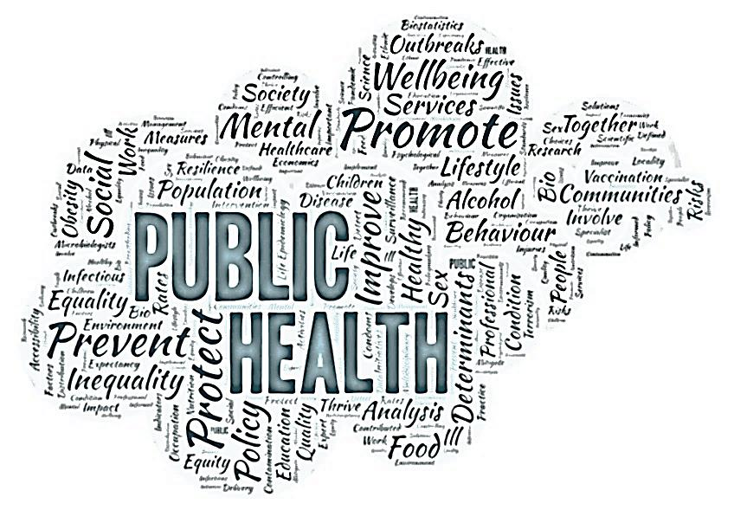

Mar-Jun 2020 | 2020-21 Quarter 1
  - This quarterly report will focus on the COVID-19 pandemic. The first part of the report will look at the epidemiology of the pandemic in Harrow and the second half will highlight some of the work that’s going on to support the vulnerable in our society and reduce health inequalities.

Quarterly Public Health Report
  - 2020-21 Quarter 1

Introduction
The COVID-19 pandemic has brought an unprecedented situation to the world.
Section 1 of this report shows the extent of the pandemic in Harrow (as at 14/06/20). It includes a variety of data that has been published nationally. Some data is not yet available at the levels that we wish to have which limits what we can put into this report at the current time. A good example of this is the lack of low level data to map the “hot spots” within the borough and the impact on Black Asian and Minority Ethnic communities. We will endeavour to update this report periodically to provide more detail as we get it and include the data on the test and trace programme as that becomes available.
In the second part of the report, I explore the key public health impacts of COVID-19 on the Harrow population and the key messages that we need to share. My team has conducted a review of the research base to consider the risks to health and wellbeing, and discuss the immediate impact of the COVID-19 outbreak on the services we commission.

KEY MESSAGES
- Harrow has seen one of the highest rates of COVID-19 cases at 414.6 per 100,000 in London (London is 304.7 per 100,000)
- Due to only testing those admitted to hospital through much of the pandemic, the true number of cases in Harrow is unknown.
- A total of 1045 lab-confirmed cases of COVID-19 had been reported in Harrow between the period 1st March 2020 to 14th June 2020
- Daily lab-confirmed COVID-19 cases in Harrow account for an average of 3.8% of total daily London cases, whilst overall Harrow accounts for 2.8% of the total London population.
- Rates of cases by age in Harrow, show that the 80+ age group had the highest rate per 100,000 population, at 1394, 42 times higher than those under 20 years (33 per 100,000)
- Harrow recorded the 6th highest death rate related to COVID-19, at 114.7 per 100,000 population in London (Newham reported the highest, at 144.3 per 100,000, the average for London was 85.7 per 100,000 population)
- Increased numbers of deaths that were not recorded as COVID related were seen during the April and June. The number of excess deaths is a better measure than COVID-19 deaths of the pandemic’s overall impact on mortality, current analysis show that around 87% of excess deaths occurring in this period were COVID-19 related.
- The impact from COVID-19 has highlighted existing health inequalities: Being male, living in more deprived areas, and being from a Black, Asian and Minority Ethnic (BAME) background were also found to be associated with worse outcomes in a national report. We do not currently have data to look at these differences in Harrow. However, BAME groups account for around 64% of the population of Harrow, nationally it has been seen that in this group up to 34% were affected critically by COVID-19

Data Sources
Data has been collected by the Office of National Statistics and Public Health England, looking at lab-confirmed daily cases and deaths by occurrence and registration, in order to establish the impacts of COVID-19, nationally, regionally and now some data at local levels.

The Curve of the Pandemic
Harrow’s first lab confirmed COVID-19 case was on the 3rd March 2020, and the data for cases has been analysed from 1st March 2020 to 14th June 2020. Between the period of 1st March to 14th June, a total of 1045 lab-confirmed cases were recorded for the London Borough of Harrow. Figure 1and Figure 2 show the cumulative confirmed cases between 1 March and 14 June and the daily number of lab-confirmed cases for this same period, respectively.
We have seen nationally that the numbers of tests recorded at weekends are lower and the cases reported on Mondays causing unexpected peaks early in the week. One of the ways we can smooth out these daily variations is to do a seven day moving average number of cases. Figure 3 and Figure 4 show the seven-day moving average number of cases in Harrow and London during the same time period. London had its first confirmed case on the 11th February, 2020.
These graphs don’t tell the whole story. Initially all symptomatic people were tested but in late March, testing was restricted to only those who were admitted to hospital. Thus many more cases were occurring in the community that have not been captured in the data. Early planning estimates for the pandemic suggested 10% of cases would require admission to hospital so the true numbers in late March and April could be 10 times higher than these numbers.

Figure 1 Cumulative daily lab-confirmed COVID-19 cases in Harrow
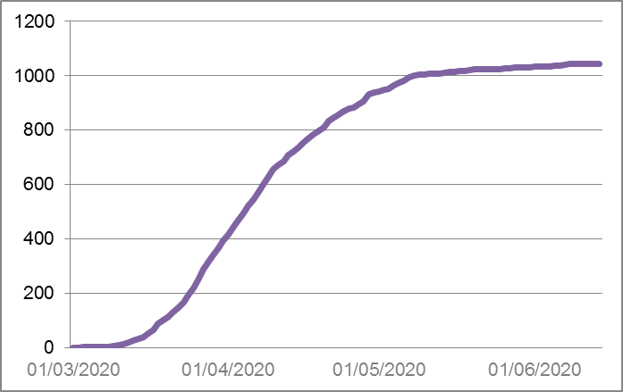
Source 1 Public Health England, accessed June 15th 2020

Figure 2 Daily lab-confirmed COVID-19 cases in Harrow
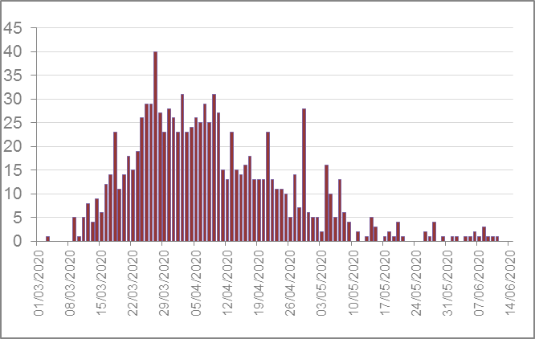
Source 1 Public Health England, accessed June 15th 2020

Figure 3 Seven-day average lab-confirmed cases of COVID-19 in Harrow
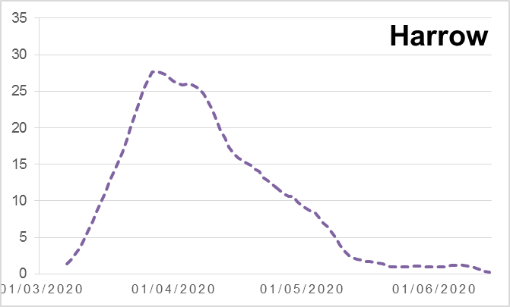
Source 1 Public Health England, accessed June 15th 2020

Figure 4 Seven-day average lab-confirmed cases of COVID-19 in London
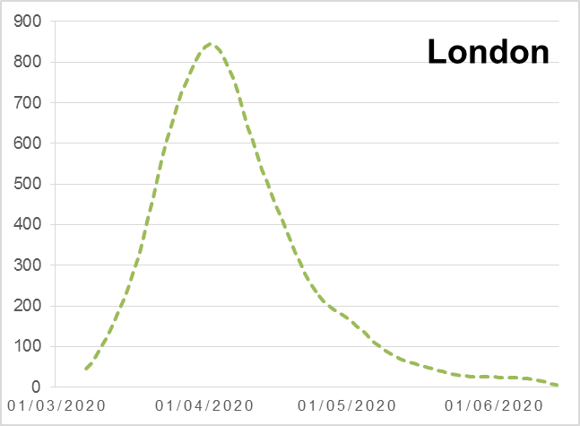
Source 1 Public Health England, accessed June 15th 2020

Rates of COVID-19 Infections
London has had the highest number of lab-confirmed COVID-19 cases in England, giving a crude rate (i.e. by dividing the number of cases by the total population numbers) of 304.7 cases per 100,000 population. Using this same method, out of the 32 boroughs in London, Harrow has had the second highest reported at 414.6 per 100,000 population. The borough of Brent has the highest, at 448.0 per 100,000 population.

Overall, Harrow had 1045 confirmed cases for this period, which was 3.8% of the total cases for London. At some points during this period, the proportion of total London cases that occurred in Harrow increased to over 5% before reducing to this average. Harrow accounts for approximately 2.8% of the London population. This illustrates the disproportionate burden of the pandemic on Harrow with crude rates of cases that are 1.35 times higher than London average.

We need to understand what has led to this disproportionally high infection rate.

Figure 5 Rate of COVID-19 cases, per 100,000 population by London Boroughs
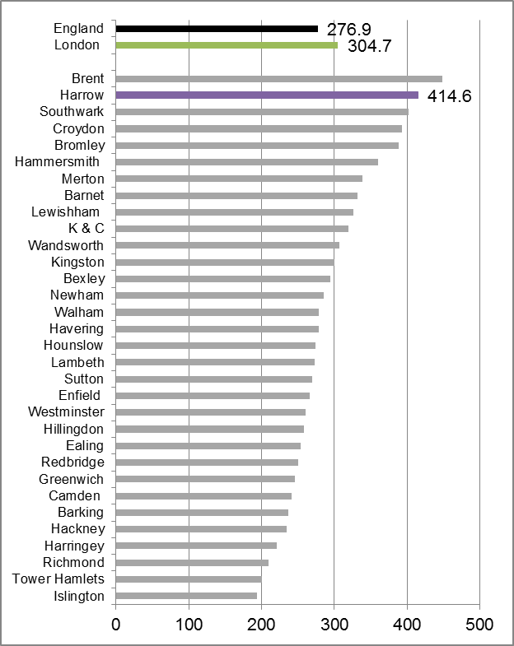
Source 1 Public Health England, accessed June 15th 2020

Age profile of COVID-19 cases
More than half of all of the cases in Harrow occurred in people of working age (20-64 years). The cases in children and young people accounted for less than 3% of cases. This is similar to the pattern seen across the country where children are either not being infected by COVID -19 or they experience very mild disease.
If we consider the age specific rates of laboratory diagnosed infection with COVID we see that the rate increases dramatically with increasing age. The 80 + group in Harrow have the highest rate per 100,000 population at 1,395 cases, which is 42 times higher than those under 20 in Harrow.
Figure 6 Total number and rates of lab-confirmed cases by age in Harrow
Age | No of Cases | % of total cases | Per 100,000 Population
0-19 | 22 | 2.9% | 33
20-39 | 162 | 21.6% | 224
40-64 | 262 | 35.0% | 324
65-79 | 137 | 18.3% | 474
80+ | 166 | 22.2% | 1395
Source 2 COVID-19 cases data by Postcode , Public Health England

Figure 7 Rate of lab-confirmed COVID-19 cases by age in Harrow, per 100,000
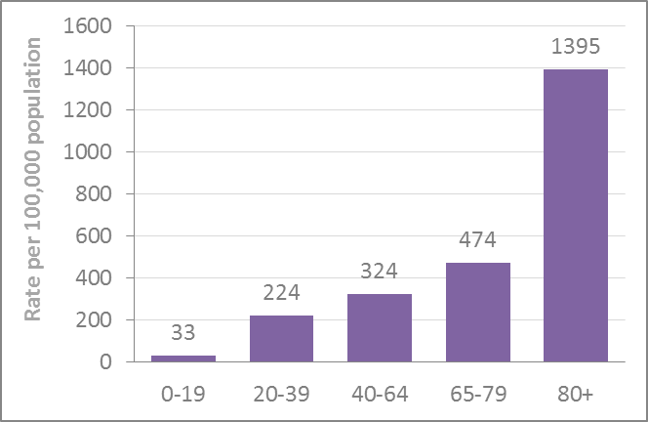
Source 2 COVID-19 cases data by Postcode , Public Health England

Mortality related to COVID-19
Between January 1st and June 5th, 1164 deaths have been registered for Harrow (registered up to June 16th). Of these, 391 mentioned COVID-19 on the death certificate. Harrow had the fifth highest number of deaths from COVID-19 in London, behind Brent, Croydon, Barnet and Ealing.
COVID-19 has been shown to disproportionately affect older people. Harrow’s population structure differs from the London average in that there is a greater proportion of older people. There are 57 residential and care homes in Harrow – a high number of compared to many other boroughs. Care home outbreaks have certainly contributed to the number of cases of COVID-19 in Harrow. Older people are more likely to become more ill from COVID-19 and require admission to hospital. To allow us to compare the rates of deaths in different boroughs, we need to adjust for size and age structure of the population. There were 36.2 deaths involving COVID-19 per 100,000 people in England and Wales. London had the highest age-standardised mortality rate (ASMR) with 85.7 deaths per 100,000 persons involving COVID-19 almost double the next highest rate.
The local authorities with the highest ASMR for deaths involving COVID-19 were all London Boroughs; Newham 144.3; Brent 141.5 and Hackney 127.4. Harrow’s ASMR was 114.7, the 6th highest amongst all the London boroughs.
Figure 8 Rate of COVID-19 related mortality by London Boroughs
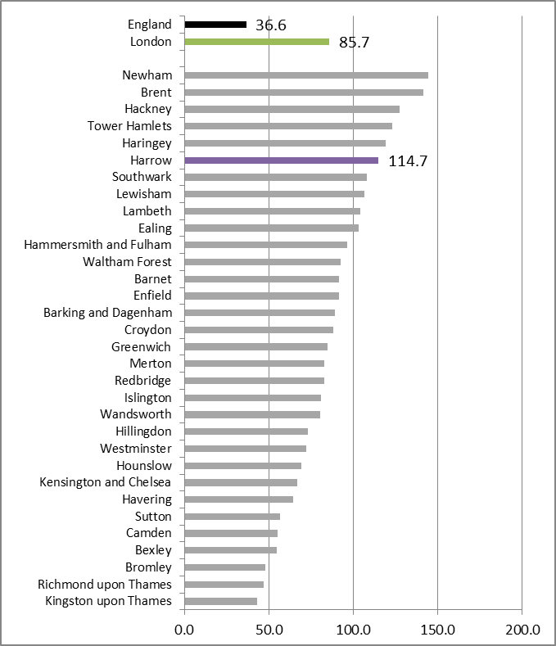
Source 3 ONS 2020, accessed June 15th 2020

Patterns of COVID-19 and Non-COVID-19 Deaths
Each year, the number of deaths occurring in the population varies with the season. Deaths in winter are higher than at other times of the year. The number of additional deaths occurring in winter each year varies depending on coldness of the winter and by the amount of circulating influenza virus- and the levels of vaccination against Influenza in the community. There is a similar but smaller increase due to heat in summer in some years.
Figure 9 Deaths by cause (registered up to 5 June 2020) by week, Harrow
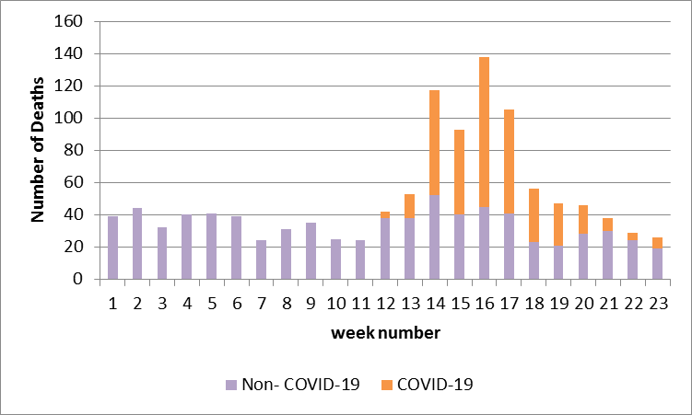
Source 4 ONS 2020, accessed June 15th 2020

Figure 9 shows the number of non-COVID-19 and COVID-19 related deaths by week from the start of the year.
The occurrence of the COVID-19 pandemic has of course affected this pattern. The first COVID-19 deaths occurred in mid March as the excess winter deaths had begun to decrease.
The majority of COVID-19 deaths in Harrow occurred in the 4 week period from 30th March to 26th April.
We can also see that in addition to the COVID-19 deaths, the number of non-COVID-19 related deaths also increased in this period to levels greater than the seasonal norm. This shows that the pandemic not only had an impact through deaths from COVID-19 but also impacted on people dying from other causes.
The number of excess deaths is a better measure of the pandemic’s overall impact on mortality than simply looking at the number of COVID-19 deaths. In addition to the deaths from or related to COVID- 19, other deaths occur which may be due to delays in accessing treatment. This may be due to availability when hospitals were overloaded or to delays in routine or planned treatments or due to patient fears of COVID-19 reducing their likelihood of attending for emergency treatment when they needed it. Some of the deaths that did not mention COVID-19 may have been due to it as not all people who died were tested for the virus.
Excess mortality is the additional deaths, or mortality, than might otherwise be expected at a given time and does not depend on how COVID-19 deaths are recorded. It is used to look at outbreaks of specific disease, or exposure to harmful circumstances such as radiation or environmental release of poisonous chemicals, or as a result of a natural disaster.
In England and Wales there were 113% more deaths than usual in the week ending 17 April 2020 – the peak week. Since then the number of excess deaths has steadily decreased towards pre-outbreak levels with the latest data for the week ending 22 May 2020 showing 24% more excess deaths than expected.
Figure 10 displays the excess deaths in Harrow during 2020 compared to the average number of deaths per week for five year period 2014-2018 (methodology used to calculate excess deaths). It shows that there were excess deaths the weeks during lockdown (week 12 onwards, March 23rd 2020) and then starts to tail off. Further analysis shows that around 87% of the excess deaths were due to COVID-19.
The majority (85%) of COVID-19 deaths occurred in hospital. Of the non-COVID-19 deaths there was a decrease in deaths in hospital and an increase in those in care homes and at home. The data does not allow us to see if these were due to lack of access to hospital services, or due to changes in services to support people in their homes/ other place of residence.
Figure 10 Harrow excess deaths
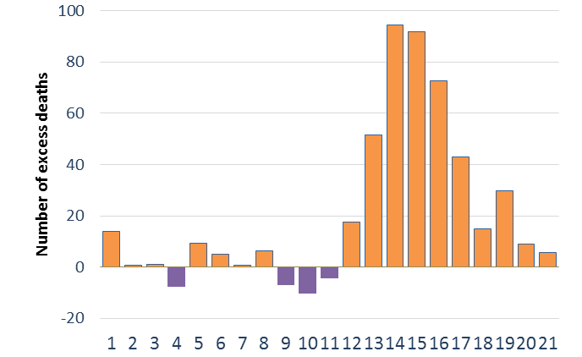
Source 5 ONS 2020, accessed June 15th 2020

Figure 11 Place of death
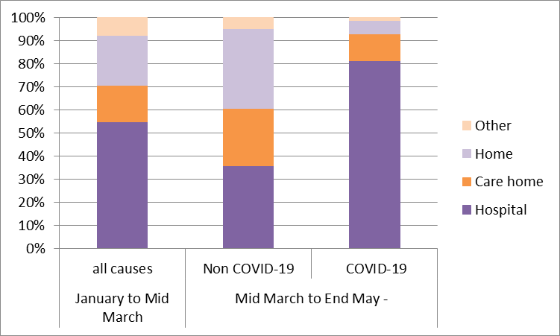
Source 6 ONS 2020, accessed June 15th 2020

Inequalities and disparities
A recent review confirms that the impact of COVID-19 has highlighted existing health inequalities and, in some cases, exacerbated them.
The largest disparity found was by age, with people diagnosed with COVID-19 who are aged 80 or older being 70 times more likely to die than those under 40. The ASMR for deaths involving COVID-19 in the most deprived areas of England was more than double that of the least deprived areas (55.1 deaths compared to 25.3 deaths per 100,000 ).
Being male, living in more deprived areas, and being from a Black, Asian and Minority Ethnic (BAME) background were also found to be associated with worse outcomes, with the racial/ethnic disparity remaining even after accounting for the effects of age, sex, deprivation and region. Figure 12 and Figure 13 show these ethnic disparities. However, the model was unable to take into account the impact of long term conditions which we know are associated with higher rates of mortality from COVID-19 and which we also know disproportionally affect the BAME communities.
Local data is not yet available to undertake analyses on these factors. We hope to be able to do so in future reports. In Harrow, the BAME population accounts for almost 64% of the total population. We also know that these groups are more prone to the long term conditions such as diabetes, hypertension, CVD, and some complex co-morbidities. This may explain why we have seen higher than average rates for both cases and deaths from COVID-19. It does not explain why we see these health inequalities but does highlight them and makes it pressing that we address them.
Figure 12 Model estimates of the likelihood of dying from COVID-19 - Males
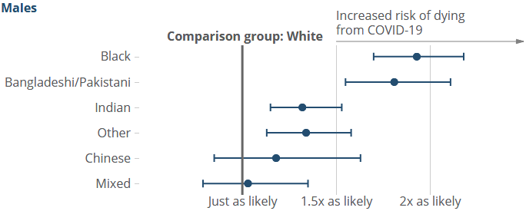

Figure 13 Model estimates of the likelihood of dying from COVID-19 - Females
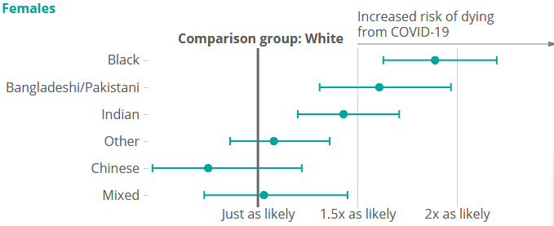
Source 7 Office for National Statistics – Coronavirus-related deaths by ethnic group

Section 2
COVID-19 is an infectious disease caused by a new virus that began as an outbreak in Wuhan, China in December 2019. It evolved into a global pandemic, with the first case of COVID-19 emerging in England in January 2020. . The COVID-19 pandemic will have a direct impact on those becoming infected but it will also have impacts on our physical and mental wellbeing. National guidance has reduced our levels of physical activity and the support mechanisms we usually rely on, this has caused worry and anxiety about the health of ourselves and others.
Early studies from China suggest a significant psychological impact of the pandemic, an increase in negative emotions (anxiety, depression) and high levels of concern for loved ones. Increased levels of stress, depression, anxiety have been observed following disasters, and during isolation and lockdown in previous outbreaks (e.g. SARS-CoV and MERS). Healthcare workers were particularly vulnerable, with high levels of psychiatric symptoms such as anxiety and post-traumatic stress disorder. The effects of restrictions in previous outbreaks were also exacerbated by duration, fears of infection, frustration and boredom, inadequate supplies, inadequate information, financial loss and stigma.
Recent surveys in the UK reveal widespread uncertainty and heightened anxiety caused by the pandemic. This is compounded by practical issues, such as worries about finances, employment and housing. There are concerns about isolation and loneliness, and reduced levels of exercise. The restrictions have also resulted in changes in behaviour, and subsequent negative impact on people’s welfare and wellbeing. In April 2020, a third of people surveyed in the UK reported sleeping less or worse than usual (38%, 35% reported eating more food or less healthy food, and 19% reported drinking more alcohol than normal.
Social distancing and lockdown has consequences for domestic abuse and risks of harm within the home. In the UK, contacts to helplines have increased, and there is evidence of more complex and violent incidents of domestic abuse. Refuges for victims are also struggling due shielding and social distancing requirements. Children are also vulnerable as the closure of schools and children’s services has resulted in reduced visibility of child victims of abuse and neglect.
The pandemic has also had an indirect impact on people with conditions not related to COVID-19. There are concerns of a significant reduction in GP and A&E attendances due to worries about contracting the virus or adding to pressure on the NHS. Non-COVID conditions may therefore be unmanaged which could have serious consequences; as seen in other pandemics. Essential and urgent services have continued during this time for people that are acutely unwell, people with long-term conditions and preventive health interventions such as childhood and adult immunisations.
In this time many of us have become more vulnerable; children, young people, older adults, people with pre-existing conditions, people on low income, socially excluded groups (e.g. prisoners, homeless, refugees) and front-line workers.

Impact on commissioned Public Health Services

Public Health advice
The Harrow Public Health team have provided advice on the risk and spread of the Coronavirus since the first case in was diagnosed in the UK. As the infection spread, PH have continued to interpret guidance and advise all health and care partners. Advice has included the appropriate use of Personal Protective Equipment (PPE) including the safe donning and doffing and facilitation of FFP3 Fit-Tests for care staff undertaking aerosol generating procedures.
Harrow PH have worked alongside Emergency Planning, Adults & Childrens Social Care, Education and other LBH Directorates to deliver a seamless provision of PPE and advice for front line staff in the Council, care homes, care home providers, carers and schools.
Public Health became the lead contact for the PPE orders for the West London Alliance and represents LBH at the weekly WLA teleconferences. PH also works with Emergency Planning, to monitor stock levels and as lead contact for WLA is responsible for reordering of PPE and approving invoices for payment.
The Public Health Team has continued to promote a healthy lifestyle, and suggest ways of achieving this during the pandemic.

Sexual and Reproductive Health
During the Covid-19 pandemic, the Harrow Integrated Sexual & Reproductive Health Service (delivered by LNWHT) nursing staff were deployed to the acute unit and wthe service was remodelled. The new service delivers a telephone consultation, prescribing and referral to a clinic appointment for emergency treatment and/or vulnerable groups. There is also an increased offer via the Sexual Health London E-Service to include simple symptomatic testing and treatment. Early Hormonal contraception remains available at a number of pharmacies in Harrow. Outreach for young people is limited and the C-card remains available for those already signed up however this is limited to Pharmacies as colleges and other sites are closed.
LNWHT services are described at: www.nwlondonsexualhealth.nhs.uk

Substance Misuse
Substance misuse includes the use and misuse of alcohol, illicit and prescribed drugs and tobacco. The following commissioned services have remodelled their offer during the pandemic:
In Harrow the Westminster Drug Project (WDP) provides an over 18 service to residents. WDP delivers virtual support to service users and the assessment/treatment hub remains open for medical assessment and high risk/urgent care. Increased collaboration with Pharmacies has included prescription collection at these sites instead of the WDP base. Telephone: 0300303 2868. Email: harrow@wdp.org.uk. The WDP also provide a smoking cessation service: HarrowStopSmoking@wdp.org.uk which has continued to provide a virtual service for smokers wishing to quit due to the higher risk of serious harm if they get COVID-19.
The Young People’s Substance Misuse Service is delivered in Harrow by Compass. The service is operating remotely, however young people will be seen if there is an urgent need/risk and also as part of wraparound care with other agencies i.e. children’s service. Telephone: 020 8861 2787 Email: adminharrow@compass-uk.org

Weight Management in Harrow
A 12 week weight management service is being delivered in association with the Watford Football Clubs Community Sports and Education Trust. Over the past few years over 120 people have been support in Harrow to reducing their weight and taking up more regular exercise and a pilot was run which provided important insights on accessibility for our priority communities that have informed the continuation of the service this year.
The service model has shown agility in the last few months and adapted to provide an online service, with a digital app due to release later in the year as planned. The South Harrow Physical Activity Community Champion project has been paused during the pandemic but we hope this will continue later this year as part of the delivery of the Active Harrow Strategy.

Health Visiting and School Nursing Service (0-19 Service) and the National Child Measurement Programme
There is a combined health visiting and school nursing services for 0-19 year olds in Harrow provided by CNWL. Harrow Health Visiting Service provides advice, support and intervention to families with children in the first years of life. The specialist team is led by health visitors, and is supported by community staff nurses, nursery nurses and administrative staff. This service is for children from birth to five years of age, and they can also offer support before baby arrives. A child’s care is transferred to a school nurse at the age of five. School health nurses are part of the Harrow School Health Service which supports the health needs of school age children, up to 19 years of age.
There has been prioritisation of community health services during the pandemic resulting in reduced services by the health visiting and school health teams. Approximately 30% of staff were redeployed to support other services. Understandably, Q4 19-20 saw a slight dip for some of the indicators as it was affected by services ceasing in the last week of March 2020.
The Health Visiting service has prioritised antenatal contact and new baby visits. Children are also assessed for vulnerability or clinical need and may consequently receive a virtual or a face to face visit. Telephone advice, support to the most vulnerable families and safeguarding work also continue during the pandemic. Furthermore, the service has had to adapt delivering most services remotely. A clinic was set up for those who needed to a face-to-face appointment where staff with PPE could see them, and the service has increased its team available by phone for support and advice. The service is now working on the recovery plan and how to deliver services safely and effectively.
One mum said:
“I was so grateful for the telephone support I received from the Health Visitor. I felt she really listened to my concerns.”

The School Nursing service was also redeployed as schools closed. Health assessments for vulnerable young people continued but most other activity stopped. Child measurements for the National Child Measurement Programme (NCMP) 2019/20 school year were suspended with the school closures. The school nursing team in Harrow had up until then completed around 70% of all measurements of children attending Harrow schools, however as we are were in the early stages of measurements, this data now needs to be validated by Public Health Intelligence . In previous years, Harrow has submitted high quality data, with participation rates of 95% and above. Public Health England and the NHS Digital NCMP team have indicated that a lower level of participation would be accepted this year, and they have not yet provided guidance for the 2020/21 programme.
The school based immunisations services are provided by CLCH. Scheduled immunisations that have not taken place will need to be caught up to avoid an unmanageable demand for services. Plans are being developed to organise appropriate catch up clinics prior to the Autumn term.

NHS Health checks
The NHS Health Check programme, which looks for undiagnosed cardiovascular and other diseases and seeks to support behaviour change to reduce the future risk, has been paused during the pandemic.

Impact on Mental health, stress and anxiety
Mental health, stress and anxiety are all forms of poor mental health. One-in-four adults and one-in-ten children experience mental illness during their lifetime. Improved mental health and wellbeing is associated with a range of better outcomes for people of all ages and backgrounds. These include better physical health, lower levels of smoking and alcohol misuse, improved employment rates, productivity and a lower risk of self-harm and suicide: Most mental disorders are more common in people living alone, in poor physical health and not employed.
Failure to address poor mental health and conduct disorder in childhood results in higher risk of suicide, substance misuse, self- harm, lower educational and employment achievement.
In England, one in eight 5-19 year olds have at least one mental disorder, with young women at particularly high risk (23.9% of 17-19 year old girls have a mental disorder). One adult in six have a common mental disorder (e.g. depression and generalised anxiety disorder) and less than one adult in a hundred (0.7%) have a psychotic disorder such as schizophrenia. Up to 15% of older people have a common mental disorder, and an estimated 60% of older people living in residential institutions are reported to have poor mental health.
Mental illness has a healthcare and human cost, in addition to a social and economic one. This can include the costs of health and social care for people with mental health problems and lost output in the economy (sickness absence, unemployment). The wider costs to the UK economy are estimated at £70-100 billion per year. There are substantial potential gains for improving mental health, including increased self‐esteem, quality of life, productivity, economic benefits and a reduction in the burden on health services.

Impact of COVID-19
Recent surveys in the UK reveal widespread uncertainty and heightened anxiety caused by the pandemic. The restrictions have resulted in changes in behaviour, and subsequent negative impact on people’s welfare and wellbeing. In April 2020, half of people (49%) surveyed in the UK reported feeling more anxious and depressed than normal, and over a third slept less or worse than usual (38%).
A significant number of people also report not being able to get the mental health support they need during the lockdown. Mind, the mental health charity, found that almost a quarter of people who have tried to access mental health services in the last two weeks have been unable to access services. This may be due to difficulties accessing GP, Community Mental Health Teams and crisis services, cancelled appointments or issues with using phone or video call technology. It is expected that the impact of the pandemic on mental health and wellbeing will be significant and long lasting.

Getting help on mental health
Harrow has a mental health service directory hosted by Mind. The services include counselling services, statutory social work services, and healthcare services. http://directory.mindinharrow.org.uk
Since 2016, the Public Health Team have invested in the Mental Health First Aid (MHFA) provision in Harrow. MHFA training helps individuals to support and signpost people that may have a mental health problem. Over 150 people have been trained so far.
In response to the Covid pandemic the national psychological first aid (PFA) course has been launched by the UK Government. PFA is the globally recognised training for delivering psychosocial care in the aftermath of an emergency event. The course explores the psychological impact of the COVID-19 pandemic and what you can do to help people cope.
https://www.futurelearn.com/courses/psychological-first-aid-covid-19

Key communication messages
- Promote the Mental Health First Aid and the Psychological Frist Aid Training
- Promote the 5 ways to wellbeing
5 ways to wellbeing
Connect - try to do something different and make a connection with someone different.  Be active - Go for a walk, or do some ‘easy exercise’, like stretching, in the morning  Take notice - Take some time to appreciate the moment and the environment around you. | Learn - Sign up for a class, or research something you’ve always wondered about  Give - Research shows that committing an act of kindness once a week over a six-week period is associated with feeling better.

Abridged - Five ways to wellbeing New Economics Foundation
For further advice during the Covid-19 pandemic please visit:
https://www.gov.uk/government/publications/covid-19-guidance-for-the-public-on-mental-health-and-wellbeing/guidance-for-the-public-on-the-mental-health-and-wellbeing-aspects-of-coronavirus-covid-19

Impact on Loneliness
Loneliness is the feeling we get when our need for rewarding social contact and relationships is not met. It is not the same as being alone. Loneliness affects both physical and mental health; increasing risk of high blood pressure and mortality, as well as depression and anxiety. Having a mental health problem can also increase feelings of loneliness.

Impact of COVID-19
The physical isolation and loss of ordinary social contacts such as work places will reduce the level of support people usually have. This is especially important for people living alone, such as the elderly and people with long term conditions. However it also affects young people, a recent survey of adults found that during the covid-19 lockdown, young people (aged 18-24) were most likely to experience loneliness. It is therefore important to keep up social networks, and explore new technologies to enable this.

Getting help on Loneliness
- A new #Let’sTalkLoneliness public campaign has been launched by the government to help tackle loneliness and social isolation during the outbreak
Website: www.letstalkloneliness.co.uk/
- Elefriends – supportive online community managed by Mind, the mental health charity
Website: www.elefriends.org.uk
- Other nationally based sources of help include:
- Silverline - www.thesilverline.org.uk
- Age UK - www.ageuk.co.uk
- Independent Age - www.independentage.org
- Samaritans - https://www.samaritans.org/how-we-can-help/

Key communication messages
Three actions for anyone feeling lonely:
- Keep in touch with friends, family and neighbours
- Ask for help if you need shopping, medicine or are feeling lonely
- Set a routine with online activities, regular tasks or by volunteering
Three actions for anyone wanting to help:
- Phone a friend or family member you think may be lonely
- Smile, wave or chat from a safe distance with a neighbour
- Help out through volunteering or picking up food, medicine or by offering regular conversation to someone living alone
For further advice please refer to: www.harrow.gov.uk/stuckathome

Impact on Bereavement
Bereavement describes the experience of losing someone important to us. Grieving from a loss is an individual experience and encompasses a range of feelings and emotions; such as sadness, shock, anger, guilt and relief. It may also be expressed in physical symptoms, such as sleep and appetite problems. Grief may strain day-to-day living for a period of time before an individual is able to process and adapt to life after loss, grief may also require specialist support from health professionals.

Impact of COVID-19
During this pandemic many Harrow residents will have experienced the loss of someone close to them, or know someone who has been bereaved. The figure below shows the excess deaths in Harrow during the height of the outbreak in April.
Feelings of grief may be intensified due to requirements to self-isolate or socially distance from friends and family; and there may be practical issues, such as arranging funerals and legal matters. Children and young people grieve as much as adults, but can react differently due to different ways of processing information and showing their feelings. Younger children may appear not to react as they do not understand that death is permanent and sometimes children will ask the same question again and again and this can be very hard for the adult; “Mummy will be back for my birthday, won’t she?” It is important to give children the time and opportunity to ask questions and talk about their feelings. Giving clear, honest and age-appropriate information, and ensuring a regular routine also help children during the grieving process. Furthermore, it is important for adults that share the bereavement to consider their own support and well-being, in order to best support the child.
PH in conjunction with the Young Harrow Foundation, Bereavement Care and Support (Harrow) and other partner organisations have hosted two webinars: one on how to support adults, and one on how to support children and young people who have been bereaved.

Getting Help on Bereavement
- Harrow Talking Therapies (IAPT) – Free NHS Service. Individual and group counselling by accredited counsellors. For traumatic bereavement and prolonged grief disorder, individual therapy is provided by CBT therapists. Sessions are offered by video conferencing or phone.
Website: cnwltalkingtherapies.org.uk Tel: 020 8515 5015
Email: Harrow.iapt@nhs.net
Facebook: www.facebook.com/HarrowTT/
- Bereavement Care and Support (Harrow). Trained volunteers provide ‘bereavement visiting’ to adults and children currently via telephone.
Tel: 020 8427 5720
Email: admin@bereavementcareandsupport.co.uk
- The Wïsh Centre. A free therapy and counselling service for young people in Harrow aged 10-25 years.
- Particular support for children is available from Childbereavementuk.org, and www.winstonswish.org.
For schools in Harrow who would like support with pupils who have been bereaved the Educational Psychology service can help:
https://www.harrowlocaloffer.co.uk/services/education/educational-psychology-service
- Other services are also listed on the Council website: https://www.harrow.gov.uk/bereavement
Key communication messages
Allow yourself time to grieve.
It may be helpful not to rush into decisions about your loved one’s possessions and personal effects
It can be useful to delay big decisions, such as moving house, so that you do not commit to making a change that you may not have had enough time or space to consider.
Try to stick to a healthy diet and engage in some form of exercise. avoid unhealthy practices and dependencies such as: fast food, alcohol, medicine, drugs etc.
As time passes, you will be reassured that any worries you had about forgetting your loved one are unfounded and that they will always be an important part of your life and memories.
If the intensity of your feelings adversely affects your daily life, do not hesitate to contact your GP.
Source: British Psychological Society: Coping with death and bereavement during the Covid-19 pandemic. 2020.

Impact on Domestic Abuse
Domestic abuse includes abuse in relationships, as well as abuse between family members, such as adolescent to parent violence and abuse. Anyone can be a victim of domestic abuse, regardless of gender, age, ethnicity, socio-economic status, sexuality or background. Domestic abuse includes physical, sexual, psychological, emotional, financial and online abuse; as well as coercive control, harassment and stalking. Domestic abuse can be fatal. Risk factors for serious harm or homicide in domestic abuse include separation (attempt to end a violent relationship), pregnancy/new birth, isolation, use of drugs and alcohol, and use of weapons. In the year ending March 2019, 5.7% of adults in England and Wales (2.4 million) experienced domestic abuse in the last year; 1.6 million women and 786,000 men. The majority of domestic abuse was between partners or ex-partners (4.2% of adults).

Impact of COVID-19
Calls and contacts to helplines have increased during the crisis. The National Domestic Abuse Helpline run by refuge reported a 49% increase in calls and contacts in the week prior to 15 April compared to the average prior to the pandemic. There are reports of more complex, serious and violent incidents of domestic abuse occurring. Refuges for victims are also struggling due to shielding and social distancing requirements. Childline reports abuse as one of the main concerns of children expressed during the pandemic, as well as mental health, reduced support, family relationships, schoolwork at home, and bullying. ¹³

Getting Help for Domestic Abuse
Hestia has launched a safe space campaign with some outlets of Boots and Superdrug pharmacies and Morrisons. Victims will be able to pick up leaflets containing details of the NationalDomestic Abuse Helpline and Hestia services and use the consultation room to contact services.
Tel: 02089078148, (Monday-Friday – 9-5pm)
Email: idva.harrow@hestia.org
Websites: https://www.hestia.org/domestic-abuse
Other local services are listed on the Council website:
https://www.harrow.gov.uk/adult-social-care/staying-safe
Key communication messages
There is never an excuse for domestic abuse, no matter what the circumstances are. The ‘Stay at Home’ instruction does not apply to escape domestic abuse.
For ways to recognise domestic abuse and ways to find help go to www.gov.uk/domestic-abuse
https://www.harrow.gov.uk/adult-social-care/staying-safe
or use #youarenotalone

Impact on Weight Management
Weight management is the control we have over our weight. It is influenced by our lifestyle and any clinical interventions. Body mass index (BMI) is calculated from your weight and height, with the result used to check if you’re a healthy weight for your age and gender. A BMI over 30 is considered obese and will increase the risk of developing conditions such as diabetes, stroke, some cancers and poor mental health.
In 2018/19 the Active Lives Survey by Sport England estimated that over half (54.8%) adults in Harrow were overweight or obese. Data from the National Childhood Measurement Programme estimates that 17.9% of Reception children (4-5 years) and 36.7% of Year 6 children (10-11 years) in Harrow were overweight or obese.
 | Harrow | London | England
Reception: Prevalence of overweight (including obesity) 2018/19 | 17.9% | 21.8% | 22.6%
Year 6: Prevalence of overweight (including obesity) 2018/19 | 36.7% | 37.9% | 34.3%
Adults (aged 18+) classified as overweight or obese 2018/19 | 54.8% | 55.9% | 62.3%
Source: PHE fingertips accessed May 2020

The environment in which our residents live affects both how active they are and what they eat. In ordinary times Fast-food, which is generally high in energy content and low in nutritional value, is both affordable and readily available all across Harrow. Both affordability and convenience we know impacts on people’s choice of food. In 2019 there were 12 Harrow schools found to have more than 4 fast-food outlets within 400m of the school. In a recent Residents survey in Harrow (2019) people in Harrow said they would like healthier convenience food options available.

Impact of Covid-19
The impact of the lock down is not yet fully understood on levels of obesity. There is some evidence that children gain more weight during summer vacations than during the structured school year, and the impact of Covid-19 could have a similar effect. However the direct impact of adults is less understood.

Help on Managing your weight
The Shape Up weight management service is provided by Watford FCs Community and Sports Education Trust for anyone with a BMI over 30 between the age of 18 and 65. It is commissioned by the Harrow Public Health Team. In 2019/20 the service helped over 130 people to manage their weight. However the service has been affected by social distancing measures, and the course has changed to an online service in April. There are 70 participants across Harrow and Herts with positive feedback. Further courses with digital options for those that find attending courses tricky with caring responsibilities will be available later in the summer and will take a form that is appropriate to the latest social distancing guidelines.

Key communication messages
If you are worried about your weight or think you might be overweight there is lots of help available.
The national One You website has ways to watch your weight, stay active and cook healthier meals even on a budget.
Please go to https://www.shapeupherts.com/do-i-qualify to make an enquiry about the local free weight management services.

Impact on Keeping Active
Physical inactivity is a leading risk factor for mortality. People who keep a physically active lifestyle are at reduced risk of many conditions such as cardiovascular disease, stroke, diabetes and obesity. Regular physical activity also improves mental health. The Chief Medical Officer recommends 150 minutes of moderate intensity activity (e.g. brisk walking, cycling), or 75 minutes of vigorous activity (e.g. running) per week for adults. Children and young people over 5 are recommended to engage in 60 minutes of moderate to vigorous physical activity per day.
Data from the Active Lives Survey show that 64.5% of adults in Harrow met the recommended physical activity guidelines in 2018/19. This is lower than rates in London (66.6%) and England (67.2%).

Impact of COVID-19
Social distancing and lockdown have had a positive impact on the attitude of people towards physical activity. Nearly two-thirds of adults in England (62%) think that being active is more important during the COVID-19 crisis, and 65% believe that exercise is helping with their mental health. One positive impact of COVID-19 is that exercise during lockdown became framed as an opportunity rather a chore. However some people are finding it harder to stay active during the crisis, such as older people, those in low income and those in urban areas.

Getting Help to get active and stay active
Staying active is recommended to keep healthy. There are lots of free opportunities for everyone to stay active in Harrowsparks, such as going for a walk or a run. Many tennis courts and golf courses are now open again in Harrow.
The Walking for Health scheme is not operating at the moment in Harrow.

Key communication messages
‘Being active- Make it a daily habit’ or after lockdown ‘Keep the daily exercise habit’.
Staying active everyday will make you feel good and boost your immune system.
Children should be active for at least an hour a day and adults are recommended to do 20-30 minutes of exercise every day. Walking counts, go for a short walk if you are not in self isolation.
To support the health and wellbeing of children while they are at home, Daily Mile have launched the #DailyMileAtHome. The aim is to encourage children to participate safely with their parents/carers in 15 minutes of jogging or running.
For older adults twice a week exercises such as yoga, weights (even lifting your shopping) or Tai Chi, will improve strength and balance. Try the online Tai Chi class provided by Zhijun Wang who is well known for Tai Chi he provides around Harrow.
https://www.harrow.gov.uk/events/event/10630/distancing-tai-chi-sessions-live-stream-via-fb-group

Alcohol
Alcohol misuse involves harmful (high-risk) drinking and alcohol dependence. Short-term risks from alcohol misuse include accidents and injuries, reckless or violent behaviour and alcohol poisoning. Long-term health risks include high blood pressure, liver disease, stroke, depression, dementia and some cancers. It is also associated with social problems, such as increased criminal activity, domestic abuse, unemployment and homelessness. Alcohol misuse is the biggest risk factor for early death, ill health and disability among 15-49 years olds in England, and the fifth most important risk factor across all ages. People in lower socioeconomic groups are at greater risk of alcohol related harm, and almost half of all alcohol-related hospital admissions occur in the lowest three socioeconomic groups.
Harrow has higher rates for admission episodes for alcohol-related conditions compared to local and national average; however rates of alcohol-related deaths are lower than average.
 | Harrow | London | England
Admission episodes for alcohol-related conditions (Broad)* per 100,000 (2018/19) | 2,729 | 2,500 | 2,367
Alcohol-related mortality per 100,000 (2018) | 26.9 | 39.4 | 46.5
*Admissions to hospital where the primary diagnosis or any of the secondary diagnoses are an alcohol-attributable code

Impact of COVID-19
Lockdown has had positive and negative impacts on peoples drinking habits. A survey of the UK public by King’s College London in April 2020 reported that 19% of people were drinking more alcohol than normal. This is similar to the findings from the charity Alcohol Change UK in April, which found that 21% of adults in the UK who drink alcohol are drinking more often since lockdown began. However, more than one in three of those who drink (35%) reported reducing or stopped drinking, and 6% have stopped drinking entirely.

Getting Help on harmful drinking
The adult substance misuse service in Harrow is delivery by WDP. Compass Harrow provides substance misuse services for children and young people. Both services are adapting the usual face-to-face support to telephone/remote where possible.

Key communication messages
To keep health risks from alcohol to a low level it is safest not to drink more than 14 units a week on a regular basis.
If you regularly drink as much as 14 units per week, it is best to spread your drinking evenly over 3 or more days. If you have one or two heavy drinking episodes a week, you increase your risks of death from long term illness and from accidents and injuries.
The risk of developing a range of health problems (including cancers of the mouth, throat and breast) increases the more you drink on a regular basis.
If you wish to cut down the amount you drink, a good way to help achieve this is to have several drink-free days each week.
Source: The Chief Medical Officers’ alcohol consumption guidelines

Impact on Child Accident prevention
Accidents to children in and around the home are a significant health issue and they are a major cause of preventable death, ill health and serious disability. Children under five years are particularly vulnerable, with many potential risks at home.
Most accidents to children occur in the living/dining room, but the most serious are heat related and falls from a height, which happen in the kitchen and on the stairs. Older children are more likely to sustain fractures and younger children have a higher percentage of burns and scalds as well as poisoning and ingestion accidents. Most home accidents are therefore preventable through increased awareness, improvements in the home environment and greater product safety.
During 2018/19, there were 13,280 A&E attendances for 0-4 year olds, and 280 hospital admissions caused by injuries for 0-14 year olds in Harrow CCG.

Impact of COVID-19
Families are likely to be more worried about the risk of serious accidents as children will be spending more time at home. This is especially relevant as 90% of accidents to children under five happen at home. A&E departments are still continuing to see serious injuries, such as injuries from burns, baking, cycling, falls and poisoning/ingesting. There is also anecdotal evidence that some older siblings may be left to look after their younger brothers or sisters while the parents work from home.

Getting help on accident prevention
The Child Accident Prevention Trust have produced a series of lockdown safety tips for parents.
https://www.capt.org.uk/Listing/Category/safety-in-lockdown
In 2017 Public Health worked closely with Northwick Park Hospital to produce the infographic that outlines the do’s and dont’s of prevention and first Aid.
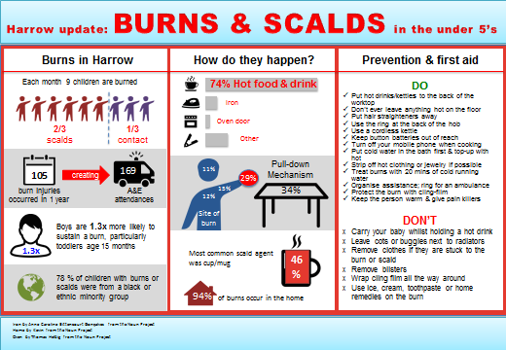

Key communication messages
Children should be supervised at all times
Keep floors free of toys and obstructions that can be tripped over
Always use a securely fitted safety harness in a pram, pushchair or highchair
Never leave babies unattended on raised surfaces
Do not place baby bouncers on raised surfaces - they could fall off with the movement of the baby
The use of baby-walkers and table-mounted high chairs is not recommended.
Source: RoSPA. Preventing accidents to children.

Impact on Childhood immunisations
Vaccines are one of the greatest impact public health interventions; and have helped eradicate and reduce cases of serious and fatal diseases. The childhood immunisation schedule provides early protection against conditions that are most dangerous for the very young; this includes diphtheria, whooping cough, polio, rotavirus, meningitis and measles.
Immunisations are an essential health service, and the childhood immunisation schedule is continuing through the pandemic. Provided children and parents are well, it is advised that childhood immunisations should proceed.
Vaccination rates for 2 year olds in Harrow before COVID-19 show that Harrow was behind the national average and lower than the 95% recommended vaccination rate. For example the percentage of children receiving one dose of MMR before the age of 2 was 85.7% in 2018/19 compared to 89.9% in England.

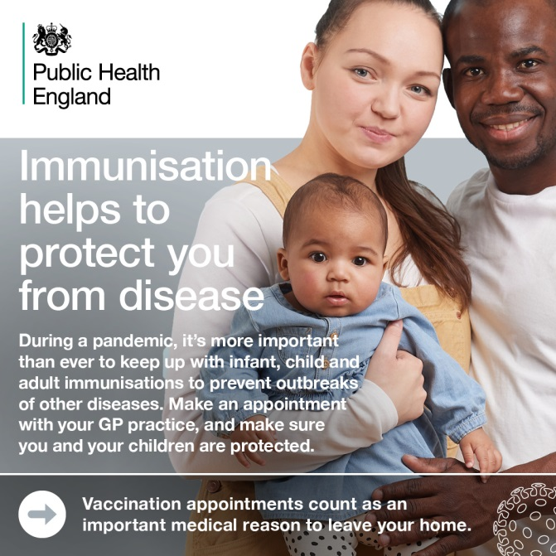

Impact of Covid-19
Childhood immunisation provisional data shows a drop by a quarter for the primary immunisations and by 15% for MMR in London. When London was already worse than the rest of the country. Public Health are working with our CCG partners and PHE London to promote greater uptake and reassure parents that it is safe to take their child to the GP practices. There is anecdotal evidence that some parents believe that if they are socially distancing there is no risk to their child of picking up diseases which is not the case for e.g. meningitis or tetanus

Key communication messages
If you have a child aged 0-5 years and they have not finished their Routine Childhood Immunisation Schedule, please make an appointment with your general practice. Your GP can vaccinate your child safely despite coronavirus.
Don’t delay, vaccinations reduce the chance of serious illness by up to 90%. Call your GP today.

References

World Health Organization. Coronavirus disease (COVID-19) Pandemic. Available here: https://www.who.int/emergencies/diseases/novel-coronavirus-2019
PHE and NHSX. Coronavirus (COVID-19) in the UK. Available here: https://coronavirus.data.gov.uk/
PHE. Guidance for the public on the mental health and wellbeing aspects of coronavirus (COVID-19). Available here: https://www.gov.uk/government/publications/covid-19-guidance-for-the-public-on-mental-health-and-wellbeing/guidance-for-the-public-on-the-mental-health-and-wellbeing-aspects-of-coronavirus-covid-19
Wang, C., Pan, R., Wan, X., Tan, Y., Xu, L., Ho, C. S., & Ho, R. C. (2020). Immediate Psychological Responses and Associated Factors during the Initial Stage of the 2019 Coronavirus Disease (COVID-19) Epidemic among the General Population in China. International journal of environmental research and public health, 17(5), 1729. Available here: https://doi.org/10.3390/ijerph17051729
Li, S., Wang, Y., Xue, J., Zhao, N., & Zhu, T. (2020). The Impact of COVID-19 Epidemic Declaration on Psychological Consequences: A Study on Active Weibo Users. International Journal of Environmental Research and Public Health, 17(6), 2032. Available here: https://doi.org/10.3390/ijerph17062032
Torales, J., O’Higgins, M., Castaldelli-Maia, J. M., & Ventriglio, A. (2020). The outbreak of COVID-19 coronavirus and its impact on global mental health. International Journal of Social Psychiatry. Available here: https://doi.org/10.1177/0020764020915212
Makwana N. (2019). Disaster and its impact on mental health: A narrative review. Journal of family medicine and primary care, 8(10), 3090–3095. Available here: https://doi.org/10.4103/jfmpc.jfmpc_893_19
Brooks, S. K., Webster, R. K., Smith, L. E., Woodland, L., Wessely, S., Greenberg, N., & Rubin, G. J. (2020). The psychological impact of quarantine and how to reduce it: rapid review of the evidence. Lancet (London, England), 395(10227), 912–920. Available here: https://doi.org/10.1016/S0140-6736(20)30460-8
The Academy of Medical Sciences. Survey results: Understanding people’s concerns about the mental health impacts of the COVID-19 pandemic. Available here: http://www.acmedsci.ac.uk/COVIDmentalhealthsurveys
King’s College London and Ipsos MORI. Life under lockdown: coronavirus in the UK. Available here: https://www.kcl.ac.uk/news/life-under-lockdown-coronavirus-in-the-uk
House of Commons Home Affairs Committee. Home Office preparedness for Covid-19 (Coronavirus): domestic abuse and risks of harm within the home. Available here: https://publications.parliament.uk/pa/cm5801/cmselect/cmhaff/321/321.pdf
The Health Foundation. COVID-19: Five dimensions of impact. Available here: https://www.health.org.uk/news-and-comment/blogs/covid-19-five-dimensions-of-impact
GP Online. Millions of patients ‘avoiding calls to GP’ during COVID-19 pandemic. Available here: https://www.gponline.com/millions-patients-avoiding-calls-gp-during-covid-19-pandemic/article/1681384
NHS England. A&E Attendances and Emergency Admissions. Available here: https://www.england.nhs.uk/statistics/statistical-work-areas/ae-waiting-times-and-activity/
PHE. Syndromic surveillance: systems and analyses. Available here: https://www.gov.uk/government/collections/syndromic-surveillance-systems-and-analyses
RCPG. Risk of “serious consequences” if non-COVID conditions unmanaged or untreated, warns College. Available here: https://www.rcgp.org.uk/about-us/news/2020/april/risk-of-serious-consequences-if-non-covid-conditions-unmanaged-or-untreated-warns-college.aspx
RCGP and BMA. RCGP Guidance on workload prioritisation during COVID-19. Available here: https://www.rcgp.org.uk/-/media/Files/Policy/A-Z-policy/2020/covid19/RCGP-guidance/202003233RCGPGuidanceprioritisationroutineworkduringCovidFINAL.ashx?la=en
Holmes, E. A., O'Connor, R. C., Perry, V. H., Tracey, I., Wessely, S., Arseneault, L., Ballard, C., Christensen, H., Cohen Silver, R., Everall, I., Ford, T., John, A., Kabir, T., King, K., Madan, I., Michie, S., Przybylski, A. K., Shafran, R., Sweeney, A., Worthman, C. M., … Bullmore, E. (2020). Multidisciplinary research priorities for the COVID-19 pandemic: a call for action for mental health science. The Lancet. Psychiatry, S2215-0366(20)30168-1. Advance online publication. Available here: https://doi.org/10.1016/S2215-0366(20)30168-1
World Health Organization Regional Office for Europe. Mental health and COVID-19. Available here: http://www.euro.who.int/en/health-topics/health-emergencies/coronavirus-covid-19/novel-coronavirus-2019-ncov-technical-guidance-OLD/coronavirus-disease-covid-19-outbreak-technical-guidance-europe-OLD/mental-health-and-covid-19
CNWL. Harrow Health Visiting Service. Available here: https://www.cnwl.nhs.uk/services/community-services/harrow-health-visiting-service
CNWL. Harrow School Health Service. Available here: https://www.cnwl.nhs.uk/services/community-services/harrow-school-health-service
NHS England and NHS Improvement. COVID-19 Prioritisation within Community Health Services. Available here: https://www.england.nhs.uk/coronavirus/wp-content/uploads/sites/52/2020/03/C0145-COVID-19-prioritisation-within-community-health-services-1-April-2020.pdf
NHS England. About mental health. Available here: https://england.nhs.uk/mental-health/about/
NHS Digital. Mental Health and Wellbeing in England. Adult Psychiatric Morbidity Survey 2014. Available here: https://files.digital.nhs.uk/pdf/q/3/mental_health_and_wellbeing_in_england_full_report.pdf
NHS Digital. Mental Health of Children and Young People in England, 2017 [PAS]. Available here: https://digital.nhs.uk/data-and-information/publications/statistical/mental-health-of-children-and-young-people-in-england/2017/2017
Richards M, Abbott, R, Collis G et al (2009). Childhood mental health and life chances in post-war Britain: insights from three national birth cohort studies. London: SCMH/The Smith Institute/Unison & MRC. Available here: https://www.scmh.org.uk/publications/life_chances.aspx?ID=596
NICE. Mental wellbeing of older people in residential care. Available here: https://nice.org.uk/guidance/qs50/documents/mental-wellbeing-of-older-people-in-care-homes-briefing-paper2
Mental Health Foundation. Fundamental Facts About Mental Health 2016. Available here: https://www.mentalhealth.org.uk/publications/fundamental-facts-about-mental-health-2016
WHO. Promoting Mental Health: concepts, emerging evidence, practice: summary report. Available here: https://who.int/mental_health/evidence/en/promoting_mhh.pdf
The Academy of Medical Sciences. Survey results: Understanding people’s concerns about the mental health impacts of the COVID-19 pandemic. Available here: http://www.acmedsci.ac.uk/COVIDmentalhealthsurveys
King’s College London and Ipsos MORI. Life under lockdown: coronavirus in the UK. Available here: https://www.kcl.ac.uk/news/life-under-lockdown-coronavirus-in-the-uk
Mind. Mental health charity Mind finds that nearly a quarter of people have not been able to access mental health services in the last two weeks. Available here: https://mind.org.uk/news-campaigns/news/mental-health-charity-mind-finds-that-nearly-a-quarter-of-people-have-not-been-able-to-access-mental-health-services-in-the-last-two-weeks/
Mind. Loneliness. Available here: https://www.mind.org.uk/information-support/tips-for-everyday-living/loneliness/about-loneliness/
Campaign to End Loneliness. Risk to health. Available here: https://www.campaigntoendloneliness.org/threat-to-health/
Mental Health Foundation. Loneliness during coronavirus. Available here: https://www.mentalhealth.org.uk/coronavirus/coping-with-loneliness
Patient. COVID-19: how to cope with loneliness during the coronavirus pandemic. Available here: https://patient.info/news-and-features/covid-19-how-to-cope-with-loneliness-during-the-coronavirus-pandemic
Let’s Talk Loneliness. Government launches plan to tackle loneliness during coronavirus lockdown. Available here: https://www.letstalkloneliness.co.uk/new-government-launches-plan-to-tackle-loneliness-during-coronavirus-lockdown/
Mind. Bereavement. Available here: https://www.mind.org.uk/information-support/guides-to-support-and-services/bereavement
Royal College of Psychiatrists. Bereavement. Available here: https://www.rcpsych.ac.uk/mental-health/problems-disorders/bereavement
ONS. Death registrations and occurrence by local authority and health board. Available here: https://www.ons.gov.uk/peoplepopulationandcommunity/healthandsocialcare/causesofdeath/datasets/deathregistrationsandoccurrencesbylocalauthorityandhealthboard
The British Psychological Society. Supporting yourself and others: coping with death and grief during the Covid-19 pandemic. Available here: https://www.bps.org.uk/sites/www.bps.org.uk/files/Policy/Policy%20-%20Files/Supporting%20yourself%20and%20others.pdf
Child Bereavement UK. Supporting bereaved children and young people. Available here: https://www.childbereavementuk.org/supporting-bereaved-children-and-young-people
Cruse Bereavement Care. How to help a child or young person. Available here: https://www.cruse.org.uk/get-help/for-parents/how-to-help-a-child-or-young-person
Home Office. Domestic abuse: how to get help. Available here: https://www.gov.uk/guidance/domestic-abuse-how-to-get-help
Women’s aid. What is domestic abuse? Available here: https://www.womensaid.org.uk/information-support/what-is-domestic-abuse/
Refuge. Recognising abuse. Available here: https://www.refuge.org.uk/get-help-now/recognising-abuse/
Reducing the Risk of Domestic Abuse. Identifying risk factors. Available here: https://www.reducingtherisk.org.uk/cms/content/identifying-risk-indicators
ONS. Domestic abuse in England and Wales overview: November 2019. Available here: https://www.ons.gov.uk/peoplepopulationandcommunity/crimeandjustice/bulletins/domesticabuseinenglandandwalesoverview/november2019
House of Commons Home Affairs Committee. Home Office preparedness for Covid-19 (Coronavirus): domestic abuse and risks of harm within the home. Available here: https://publications.parliament.uk/pa/cm5801/cmselect/cmhaff/321/321.pdf
NSPCC. What children are saying to Childline about coronavirus. Available here: https://learning.nspcc.org.uk/media/2195/what-children-are-saying-to-childline-about-coronavirus.pdf
Hestia. Campaign launches safe space in Boots stores for victims of domestic abuse across the UK. Available here: https://www.hestia.org/news/press-release-campaign-launches-safe-space-in-boots-stores-for-victims-of-domestic-abuse-across-the-uk
Hestia. Superdrug joins Safe Spaces scheme for victims of domestic abuse. Available here: https://www.hestia.org/news/superdrug-join-safe-spaces-scheme-for-victims-of-domestic-abuse-almost-a-quarter-of-all-uk-pharmacies-now-taking-part
Hestia. Morrisons opens Safe Spaces for those experiencing domestic abuse. Available here: https://www.hestia.org/news/morrisons-opens-safe-spaces-for-those-experiencing-domestic-abuse
NHS. Obesity. Available here: https://www.nhs.uk/conditions/obesity/
PHE. Public Health Outcomes Framework. Available here: https://fingertips.phe.org.uk/public-health-outcomes-framework#page/0/gid/1000042/pat/6/par/E12000007/ati/202/are/E09000015/cid/4/page-options/ovw-do-0
Harrow Public Health. Harrow Obesity Needs Assessment 2020.
PHE. Everybody active, every day: an evidence-based approach to physical activity. Available here: https://www.gov.uk/government/publications/everybody-active-every-day-a-framework-to-embed-physical-activity-into-daily-life
Department of Health and Social Care. UK Chief Medical Officer’s physical activity guidelines. Available here: https://www.gov.uk/government/publications/physical-activity-guidelines-uk-chief-medical-officers-report
PHE. Public Health Outcomes Framework. Available here: https://fingertips.phe.org.uk/public-health-outcomes-framework#page/0/gid/1000042/pat/6/par/E12000007/ati/202/are/E09000015/cid/4/page-options/ovw-do-0
Sport England. New exercise habits forming during coronavirus crisis. Available here: https://www.sportengland.org/news/new-exercise-habits-forming-during-coronavirus-crisis
NICE. Alcohol-use disorder: diagnosis, assessment and management of harmful drinking (high-risk drinking) and alcohol dependence. Clinical guideline [CG115]. Available here: https://www.nice.org.uk/guidance/cg115
NHS. Alcohol misuse. Available here: https://www.nhs.uk/conditions/alcohol-misuse/
PHE. The public health burden of alcohol and the effectives and cost-effectiveness of alcohol control policies: an evidence review. Available here: https://www.gov.uk/government/publications/the-public-health-burden-of-alcohol-evidence-review
PHE. Local Alcohol Profiles for England. Available here: https://fingertips.phe.org.uk/profile/local-alcohol-profiles
King’s College London and Ipsos MORI. Life under lockdown: coronavirus in the UK. Available here: https://www.kcl.ac.uk/news/life-under-lockdown-coronavirus-in-the-uk
Alcohol Change UK. Drinking during lockdown: headline findings. Available here: https://www.alcoholchange.org.uk/blog/2020/covid19-drinking-during-lockdown-headline-findings
Department of Health and Social Care. UK Chief Medical Officers’ Low Risk Drinking Guidelines. Available here: https://www.gov.uk/government/publications/alcohol-consumption-advice-on-low-risk-drinking
CONSUMER SAFETY UNIT. 24th Annual Report, Home Accident Surveillance System. London: Department of Trade and Industry, 2002.
PHE. Child Health Profiles. Available here: https://fingertips.phe.org.uk/profile/child-health-profiles/data#page/1/gid/1938133228/pat/46/par/E39000018/ati/165/are/E38000074/cid/4
CAPT. Preventing accidents in home. Available here: https://capt.org.uk/news/preventing-accidents-in-the-home
RCNi. COVID-19: how lockdown affects children’s risk of home accident injury. Available here: https://rcni.com/emergency-nurse/newsroom/analysis/covid-19-how-lockdown-affects-childrens-risk-of-home-accident-injury-161116
PHE. Infographic of the impact of vaccines in England and Wales. Available here: https://www.gov.uk/government/publications/vaccines-work-infographic
PHE. UK immunisation schedule: the green book, chapter 11. Available here: https://www.gov.uk/government/publications/immunisation-schedule-the-green-book-chapter-11
PHE. Vaccines throughout life: infographic. Available here: https://www.gov.uk/government/publications/vaccines-throughout-life-infographic
Royal College of Nursing. Maintaining the National Immunisation schedule during COVID-19. Available here: https://www.rcn.org.uk/-/media/royal-college-of-nursing/documents/clinical-topics/public-health/maintaining-the-national-immunisation-schedule-during-covid-19.pdf?la=en&hash=7F5D4E8A84C84E9AD1640B1A5A4A99BF
PHE. Child Health Profiles. Available here: https://fingertips.phe.org.uk/profile/child-health-profiles/data#page/1/gid/1938133228/pat/46/par/E39000018/ati/165/are/E38000074/cid/4

